Surface Sterilization of Leaf Tissues
- Take the leaf and cut it into a small piece such that it covers half portion of the lesion and some portion from the green area of the leaf.
- In the laminar hood, prepare five containers as following:

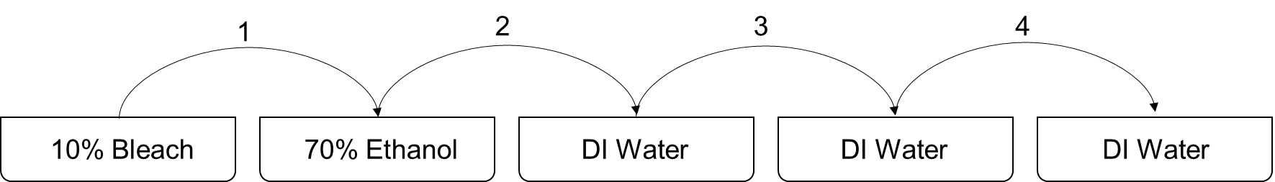

- Dip the tissues in each container for about 2 minutes, and transfer to the next after every 2 minutes.
- After the last dip, put the samples on a tissue and let them dry.
- Transfer them one by one on a PDA plate.

